2021 Teener Baseball Field Outfield Advertising
Business Name:___________________________________________
Contact Person:___________________________________________
Address:__________________________________________________
City, State, Zip:____________________________________________
Phone:_____________ Email:________________________________
Player:___________________________________________________
____ $300 – renewal of existing banner advertising
Teener Field Size 6 x 8 feet
All Outfield Sponsors will be designated a Tournament Sponsor at 1 of 3 Post 164 Tournaments!
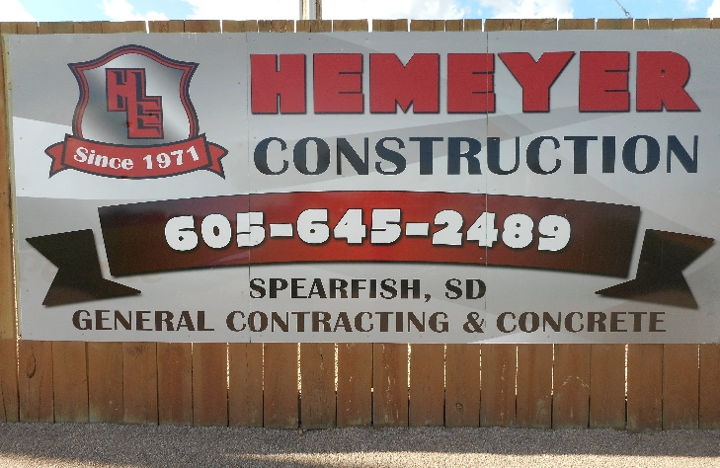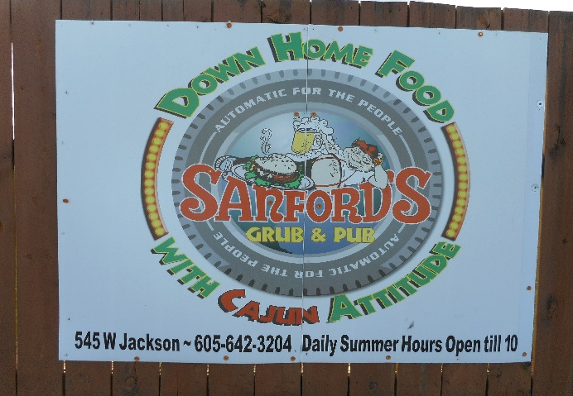
For more information: Penny Shuster Louks 605-645-0720 or pslouks@rushmore.com
Checks payable to: Spearfish American Legion Baseball
Mail to: SALB PO Box 501 Spearfish, SD 57783

Due: March 15, 2021 Advertising Contract

